NIST Cloud Computing Definition

* On-Demand self-service
* Broad network access
* Resource pooling
* Rapid elasticity
* Measured service

Service Models

* Infrastructure as a Service (IaaS)
* Platform as a Service (PaaS)
* Software as a Service (SaaS)

Deployment Models

* Private Cloud
* Community Cloud
* Public Cloud
* Hybrid Cloud

Infrastructure & Applications

* Resiliency
* Security
* Durability
* Performance
* Cost-effectiveness
* Scalability
* Automation

Process & Workflow

* Agile
* Flexible
* Efficient
* Secure

Business

* Secure, reliable data center
* Low CapEx
* No long-term commitments
* Fast time to market

**AWS**

Compute

* Amazon EC2 (Virtual Machines)
* AWS Lambda (Serverless Computing)
* Amazon Elastic Container Service (ECS)

Storage

* Amazon Elastic Block Store (EBS)
* Amazon Simple Storage Service (S3)
* Amazon Glacier

Application Services

* Simple Notification Service (SNS)
* Simple Email Service (SES)
* Simple Queue Service (SQS)

Datastores

* Relational Databases Services (RDS)
* DynamoDB
* ElastiCache
* Cassandra/Mongo (on EC2)

Analytics

* Amazon Kinesis
* Amazon Elasticsearch Service
* Amazon Redshift
* Amazon EMR
* Amazon Athena

Networking

* Amazon Virtual Private Cloud (VPC)
* Subnets
* Routing
* Network Access Control Lists
* Security Groups

Development/Deployment

* AWS CodeCommit
* AWS CodeDeploy
* AWS CodeBuild
* AWS CodePipeline
* AWS Elastic Beanstalk
* AWS OpsWorks

AWS Provides

* On-demand Services: Get what you need when you need it
* Pay as you go: Pay for what you use, use what you need
* No long-term commitments: Feel free to throw things away when it is no longer needed
* Highly Automated: Provided repeatable infrastructures
* Managed Services: Inherent high-availability, Security, durability

We Benefit

* OpEx over CapEx
* Gain Flexibility, agility
* Immediate scalability
* Lower time to market
* Lower variable cost
* Lower upfront cost
* Easier cost allocation
* Stop running data centers

Choosing a Region

* Available services and features
* Cost of Services
* Latency, proximity to users
* Disaster recovery
* Security & Compliance

**Well-Architected Infrastructure**

* Reliable
  + Fault tolerance
  + High availability
  + Durability
* Secure
* Performant
* Cost-effective
* Operationally Excellent
  + Monitored
  + Automated
  + Effective Processes

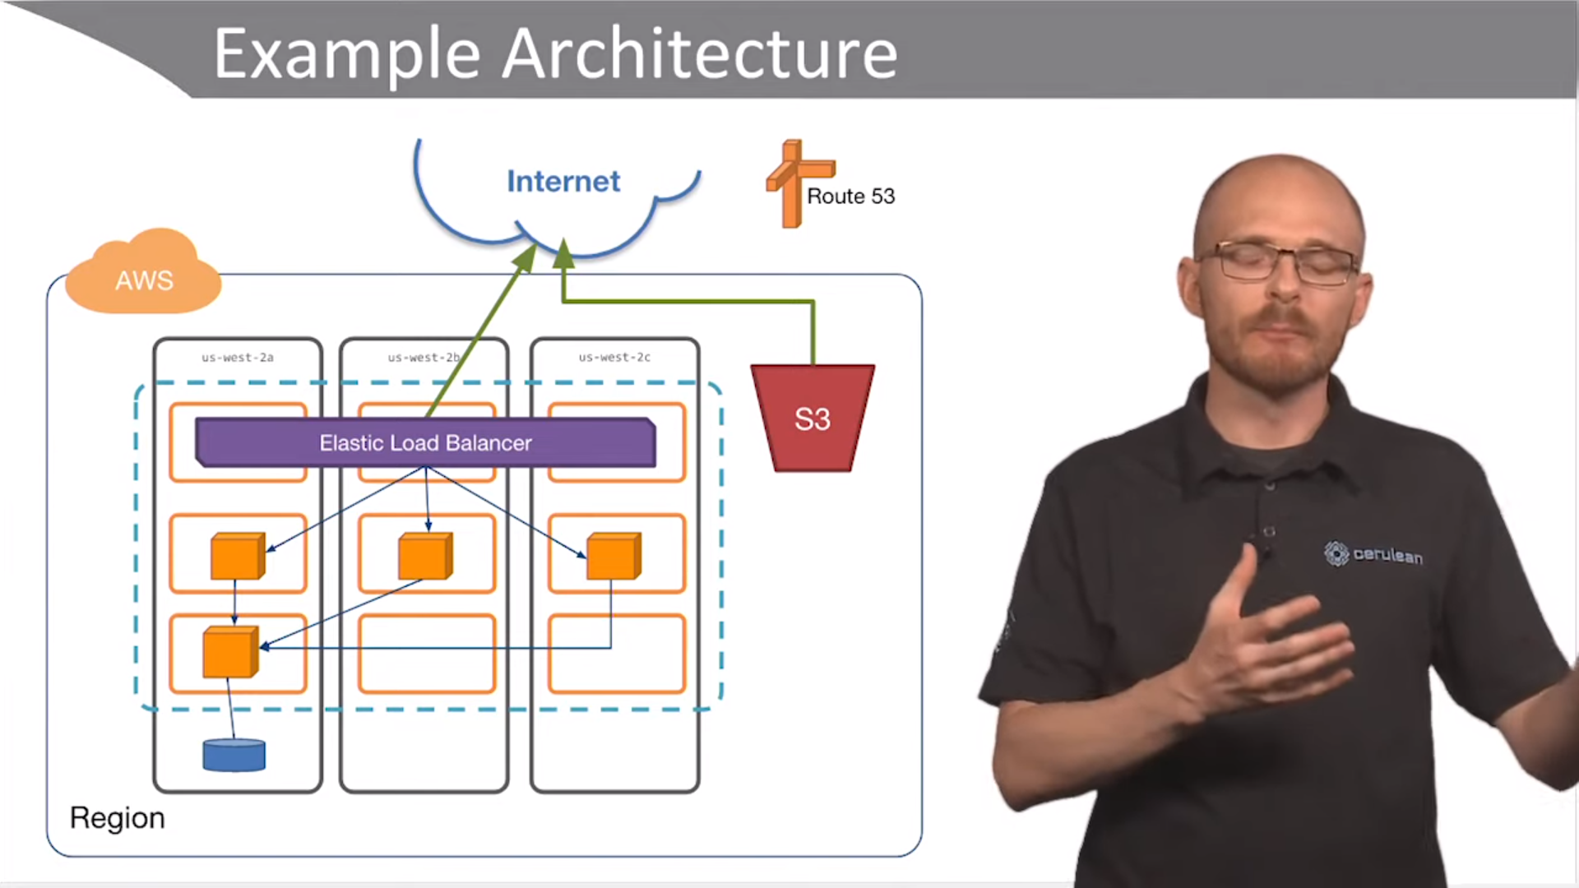

Amazon VPC

* Logically isolated network
* Created per account per Region
* Spans a single Region
* Can use all Availability Zones within one Regions
* Can peer with other VPCs
* Internet and VPN gateways
* Numerous security mechanisms
* 5 VPCs per Region
* It is possible to have 2 VPCs with different IP range or same IP Ranges

Subnets

* We have to divide VPCs into subnets
* Subnets are tied 1 to 1 with Availability Zones in a Region

Subnets Enables

* Security via isolation
* High-Availability
* Fault-Tolerance
* Performance

Three-Tier Architecture

1. Load Balancing Tier (Public)
2. Application Tier (Private)
3. Database Tier

Three-Tier Architecture needs

* Internet Access
* Isolation & Security
* High-Availability
* Fault-Tolerant

Routing